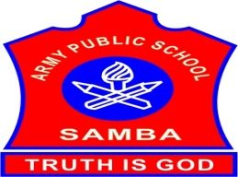
ARMY PUBLIC SCHOOL SAMBA
SCHOOL REPORT
OCTOBER 03,2023 - OCTOBER 14,2023

SCHOOL EVENTS

CLEANLINESS DRIVE BY NCC CADETS (OCTOBER 04,2023)

A Cleanliness drive and awareness rally was conducted by NCC Cadets of APS Samba on October 04,2023. A series of activities were conducted on this occasion including collection of Plastic waste and garbage from the school premises and an awareness rally regarding the least use of single used plastic items. During the rally cadets were chanting the slogan of Clean India Green India, Say No to Plastic, Swachh Bharat Swasth Bharat etc. More than 30 cadets took part in the event with full zest and zeal.

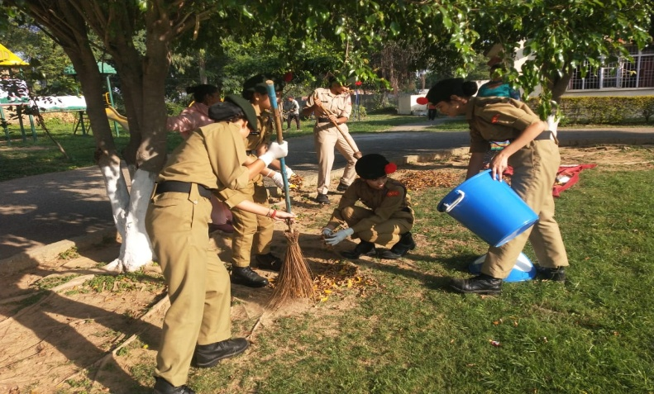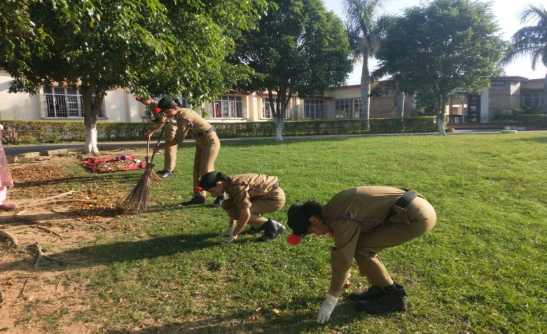

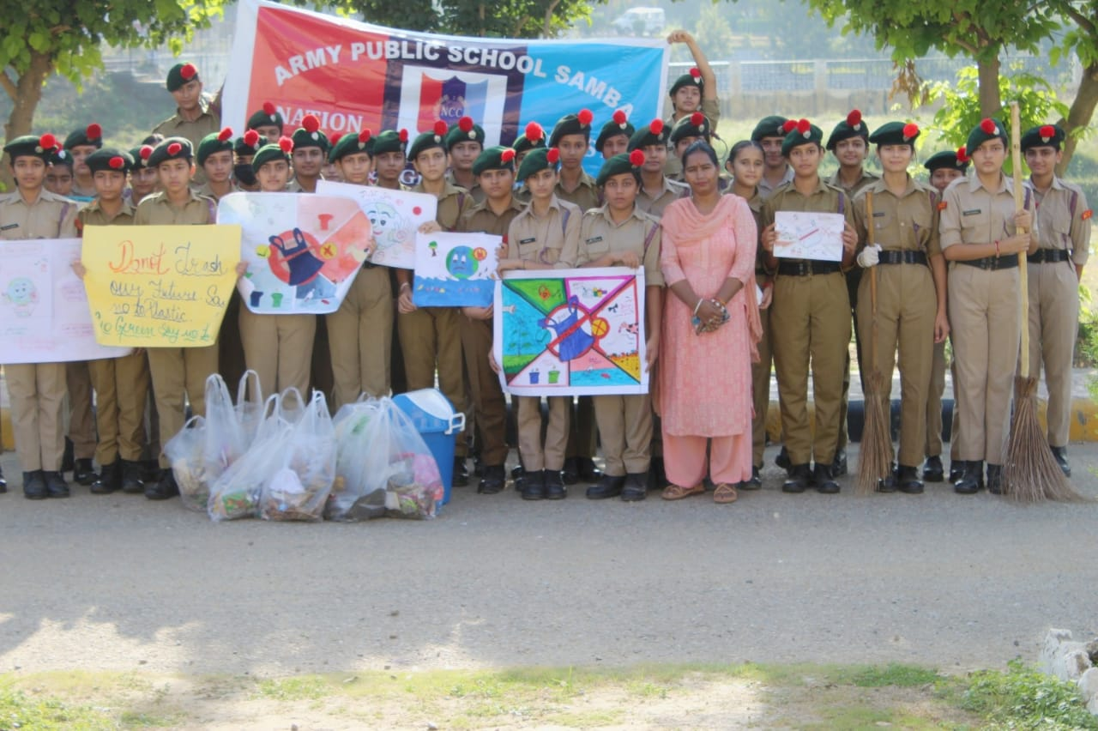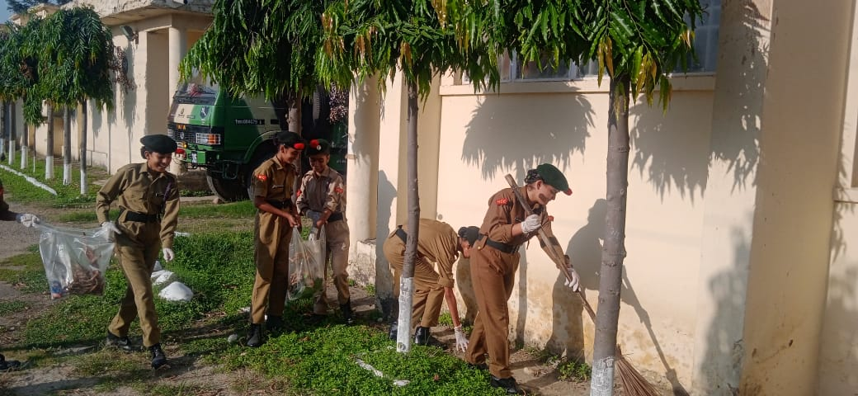

GANDHI JAYANTI CELEBRATION (OCTOBER 04,2023)

Every year October 2nd is celebrated as Gandhi Jayanti all over the country. To revere this day, the students and teachers of APS Samba held a Special Assembly on October 04, 2023 to commemorate the Mahatma’s life and teachings.The Student led choir sung a patriotic song with full exuberance. Gandhian ideals were also depicted through the song sung by them.
A special speech with Gandhian quotes and messages by Ishan Pandey,a student of class IX brought the audience
to understand more about this iconic leader. All our Students were imbued with Gandhian values and thoughts.

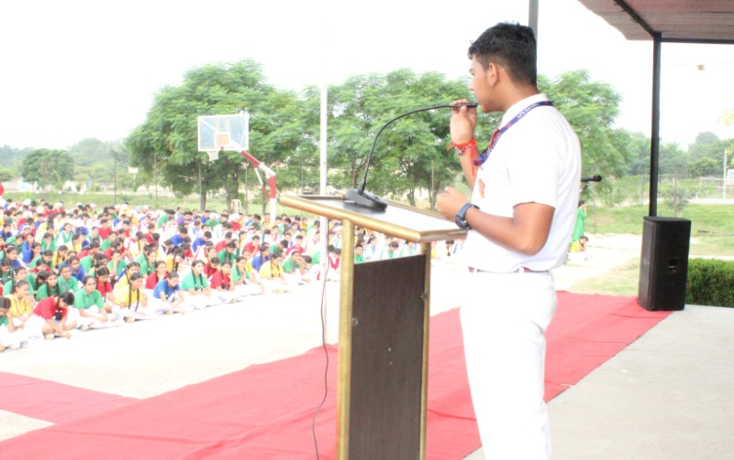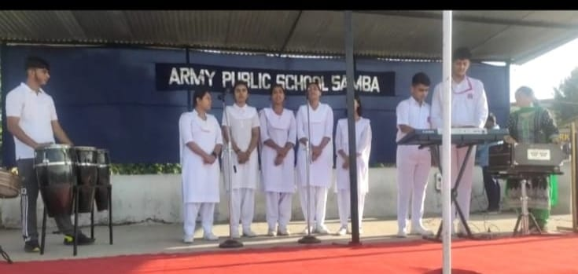

CLEANLINESS DRIVE ON GANDHI JAYANTI (OCTOBER 04,2023)
A Cleanliness Drive was also organized on Gandhi Jayanti by the senior students of APS Samba on October 04,2023.The campaign was organized to promote cleanliness and hygiene practices amongst students.Volunteers cleaned the canteen area,parks, and parking areas of the school, removing litter and waste materials.
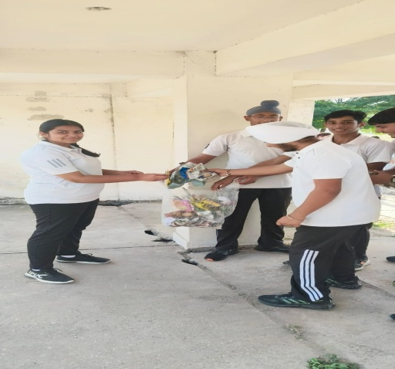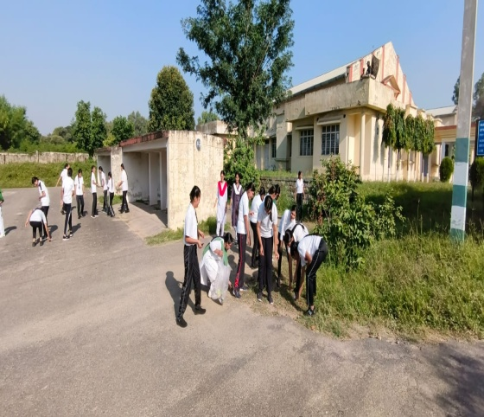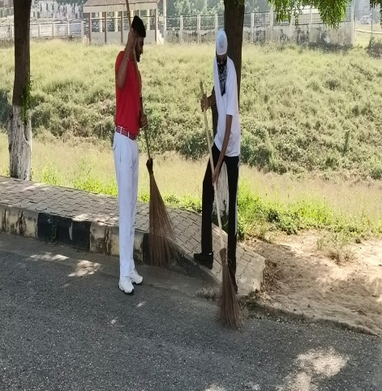
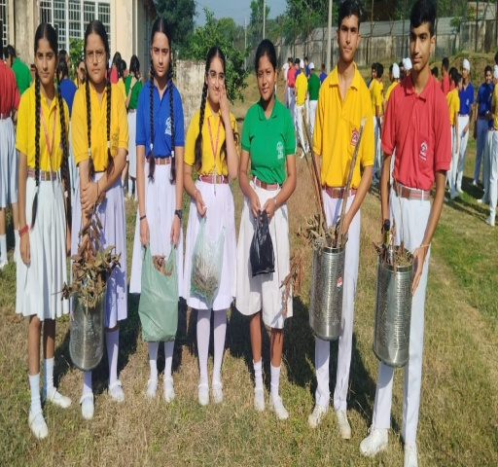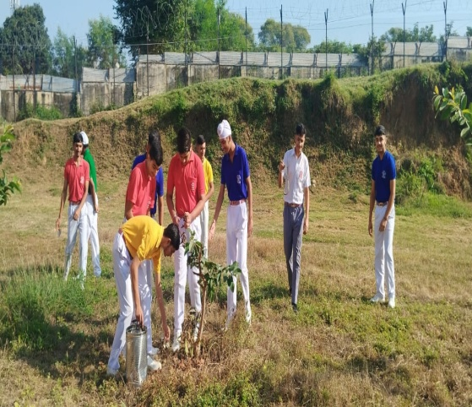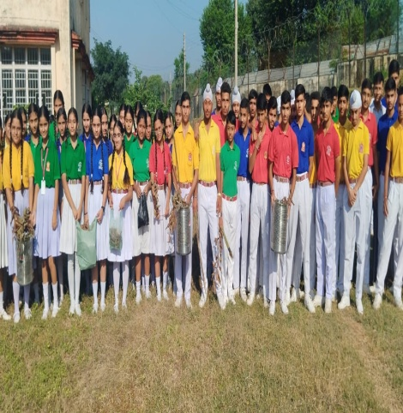

NIAS-ALC SESSION( OCTOBER 04,2023)
Session of NIAS- ALC was conducted on October 04,2023.The topic of discussion for the class was- “ History of Maths, square roots and cube roots. Class was fully interactive and students took part in the discussion with great interest.
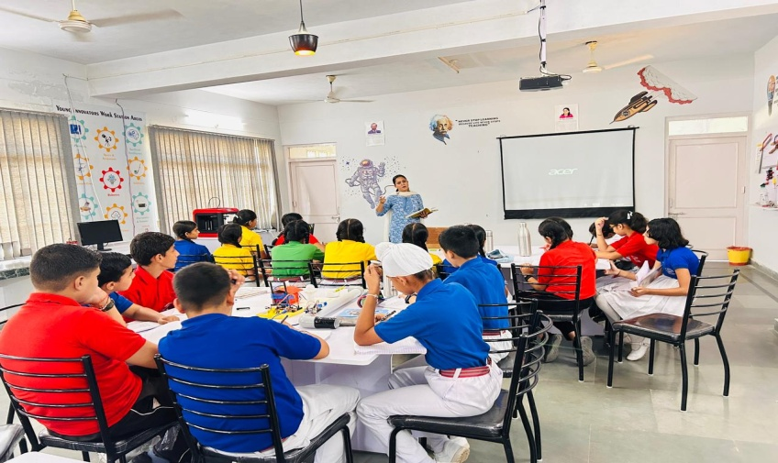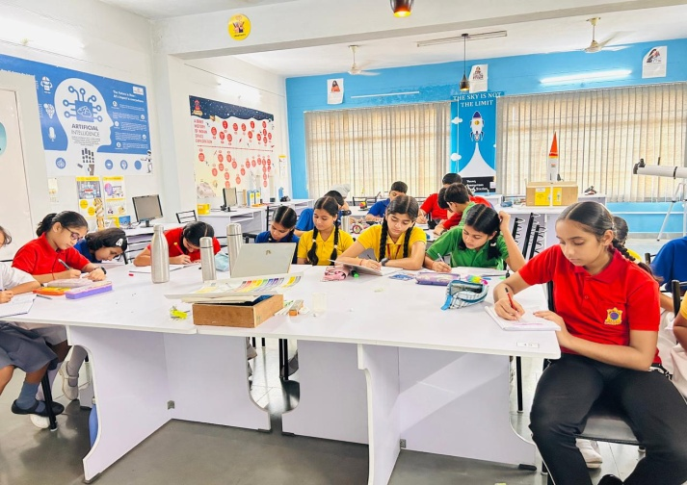
NCC DRILL PRACTICE AND CLASS ON WEAPON TRAINING (OCTOBER 04,2023)
To help NCC cadets in the mass movement in an orderly manner from point to point, to inculcate a sense of discipline, smartness, alertness and to develop a quality of immediate response to the orders, a drill practice was given to the NCC Girl cadets by Nb Sub Joginder Singh on October 04,2023 at APS Samba. Class on ‘WEAPON TRAINING’ was also conducted for the NCC cadets. Total 42 cadets were present in the training.
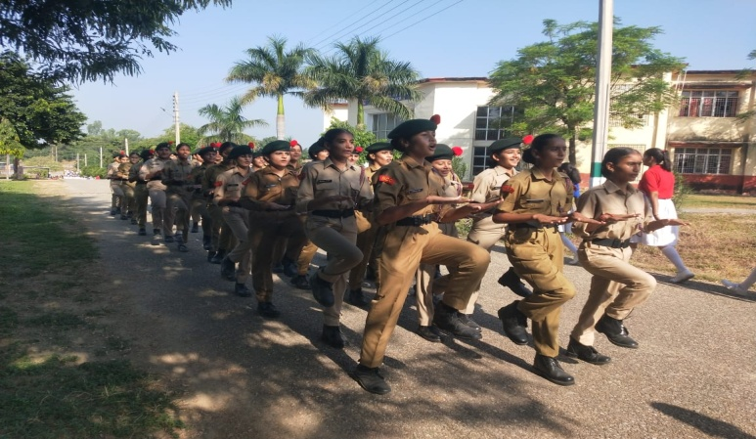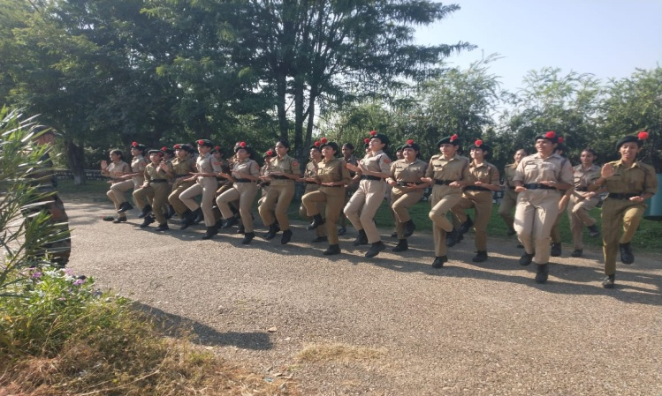
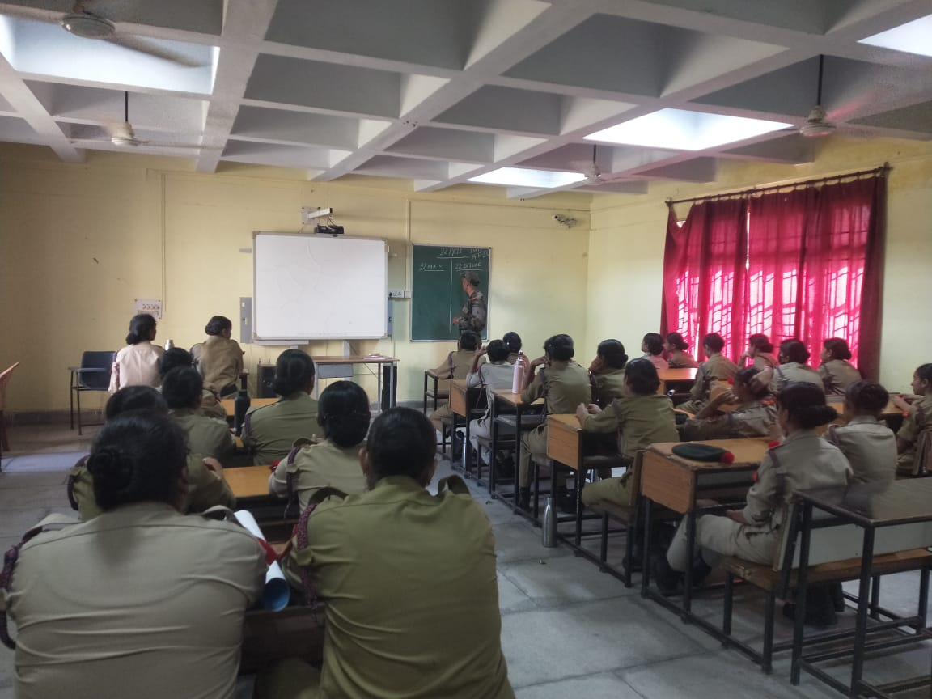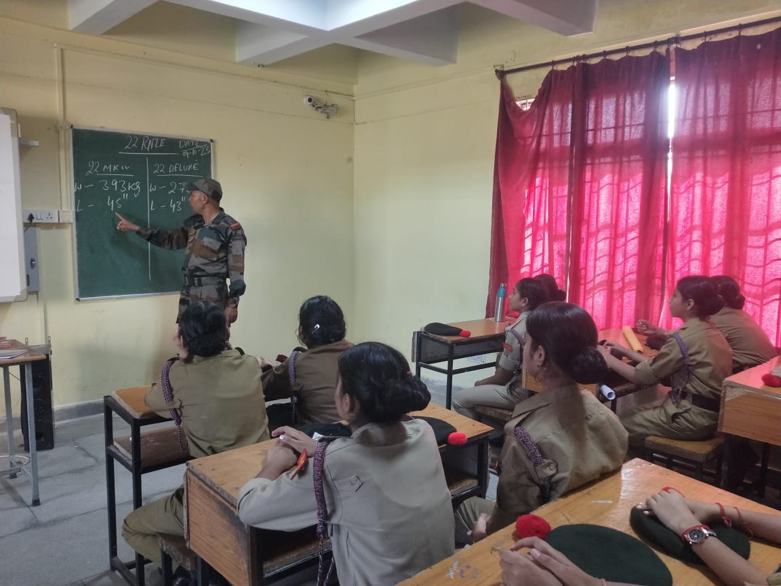

CAPACITY BUILDING PROGRAMME (OCTOBER 04-05,2023)
CBSE Panchkula organised a two days Capacity Building Programme at Heritage School Jammu on October 04-05, 2023 to benefit the teachers of the Jammu region .
Around 57 teachers from different CBSE affiliated schools hailing from different parts of state participated in the programme. The resource persons for the same were Ms Sonika Sharma, Principal Gobind Public School Dinanagar and Ms Rakhi Gupta from DPS, Udhampur.
Ms Arti Bala and Mr Pushpinder Singh,(TGT S.St) were detailed from APS Samba to attend the workshop.
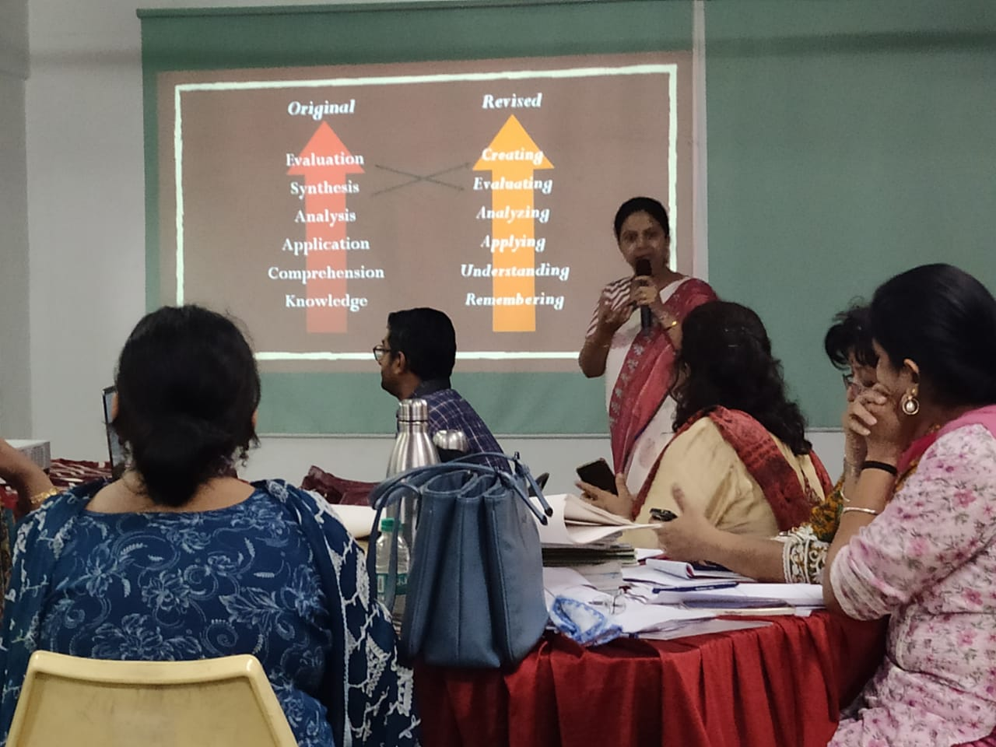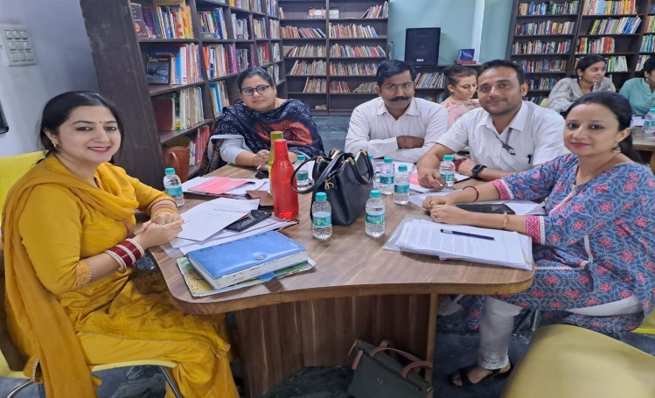
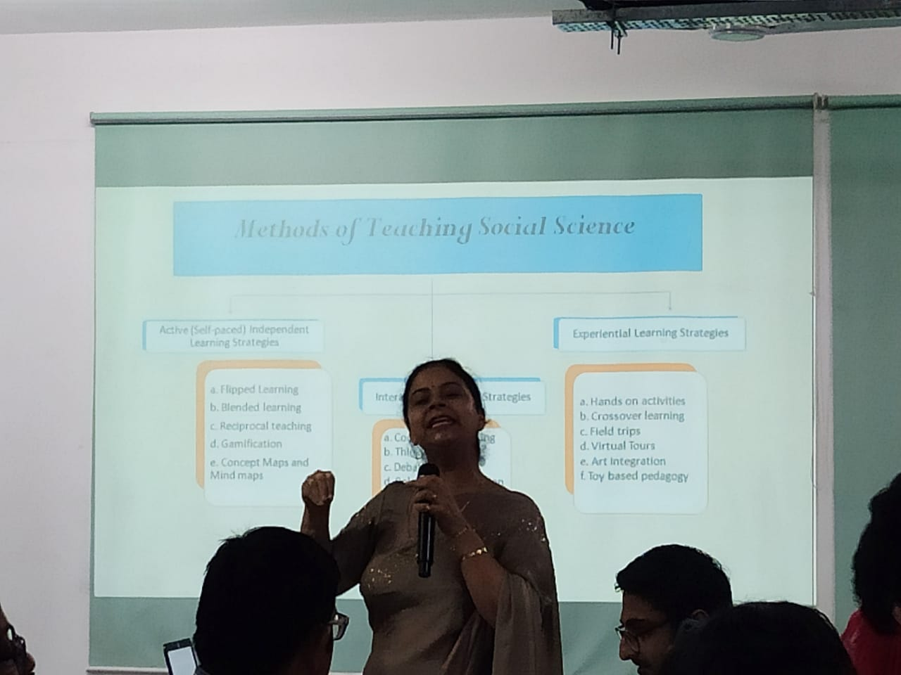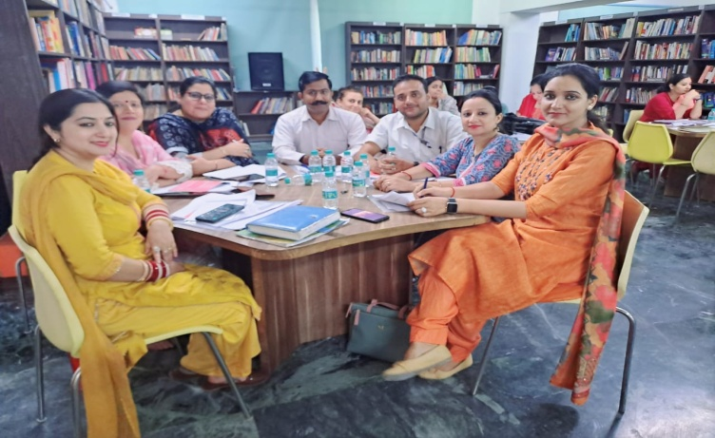
INTER DISTRICT DIVISION LEVEL BASKETBALL TOURNAMENT (OCTOBER 06,2023)

An Inter District Division Level BasketBall tournament was organized by Jammu And Kashmir Department of Youth Services and Sports on October 06,2023 at APS Udhampur. Students from APS Samba also participated in this tournament. 2 girls of class X, Mania Sharma and Rupali Sharma from APS Samba got silver medals and one girl is selected for UT Level tournament.
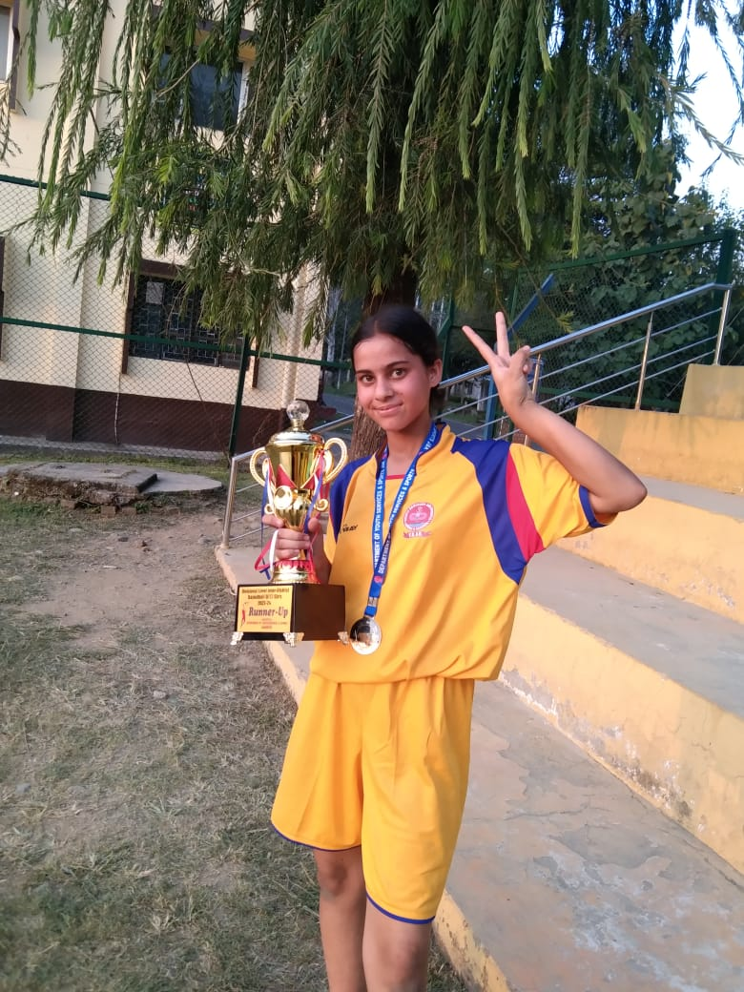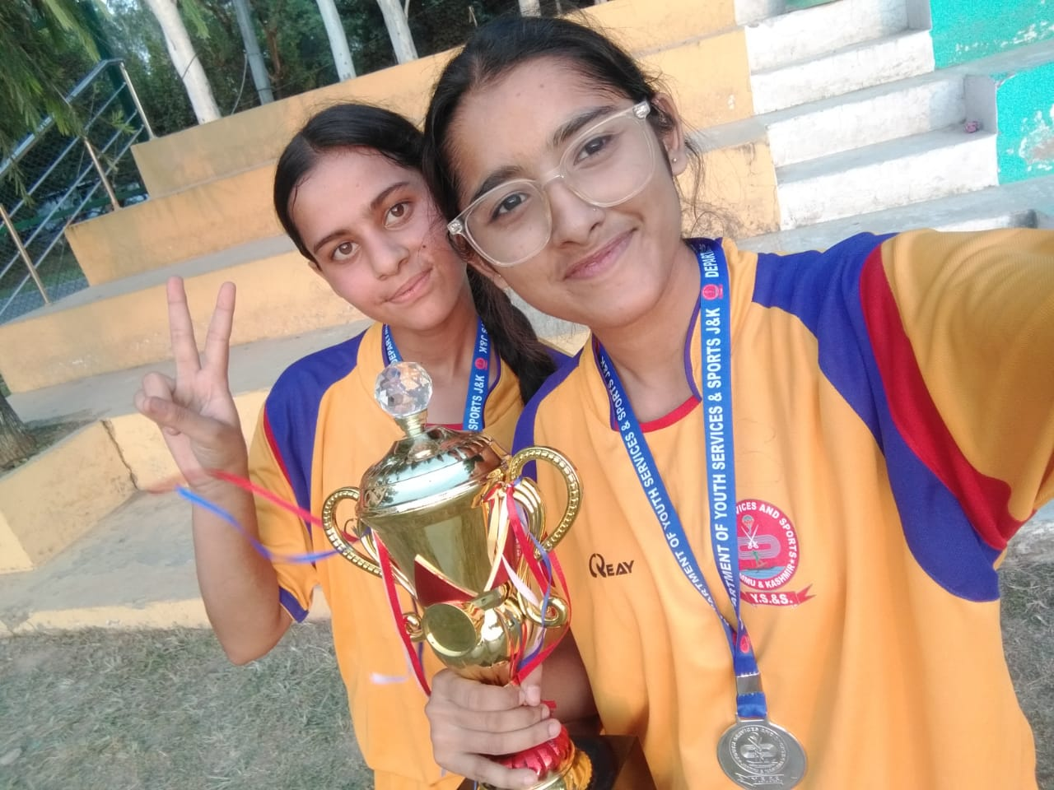

PTM FOR HALF YEARLY EXAMS III-XII (OCTOBER 05-06,2023)
A parent Teacher Meeting for classes III to XII was held on October 05-06,2023 to discuss the performance of students with their parents in Half Yearly Exams. Parents were given feedback regarding their ward’s performance in the the Half Yearly exams.
In this PTM, almost 90% parents turned up which is incredibly a bench mark for everyone of us and it reflects the diligence and commitment of every staff member.
There were no any major queries from the parents. Almost all the parents were satisfied with the work culture and mechanism of imparting quality education to the students.
It is apparently visible from the feedback of parents that ultimately ones hardwork pays off and this should be one's belief and ideology as there is no alternative to the hardwork and perseverance.
INTER SCHOOL TABLE TENNIS CHAMPIONSHIP (U-17 GIRLS) (OCTOBER 06,2023)
An Inter School Table Tennis Championship for U-17 girls was held at Birla Open Minds International School Channi, Jammu on October 06,2023. Students from APS Samba also participated in this championship.
Three girls of our school : Himanika Badgal –VIIE, Muskan Badgal-IXE and Tanya Choudhary-Xl C got
Gold medal in this championship.
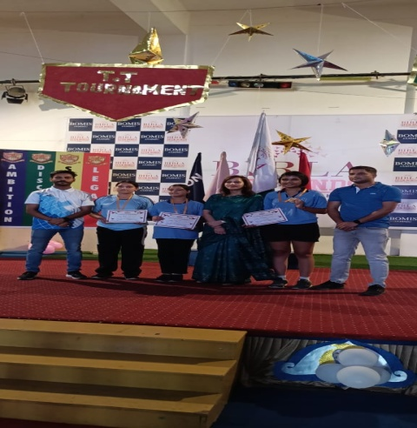

INTER DISTRICT DIVISION LEVEL BADMINTON COMPETITION FOR U-14 BOYS (OCTOBER 10,2023)

An Inter District Division Level Badminton competition for U-14 Boys organized by Department of Youth Services and Sports was held at Samba Stadium on October 10,2023.Team of APS Samba bagged second position in this competition.
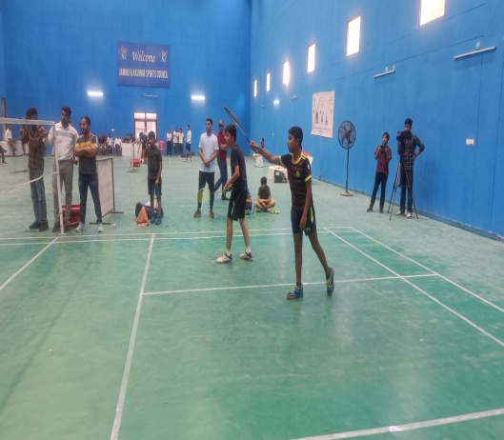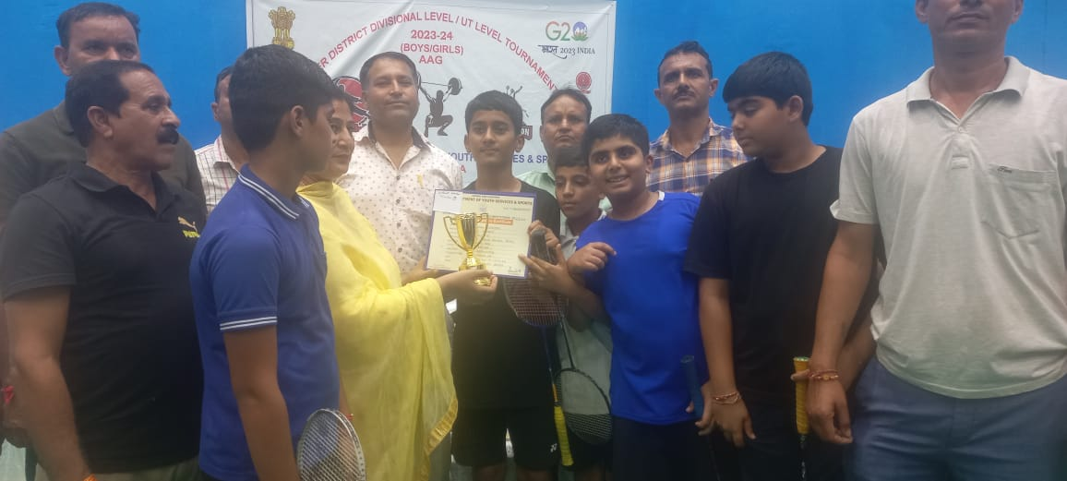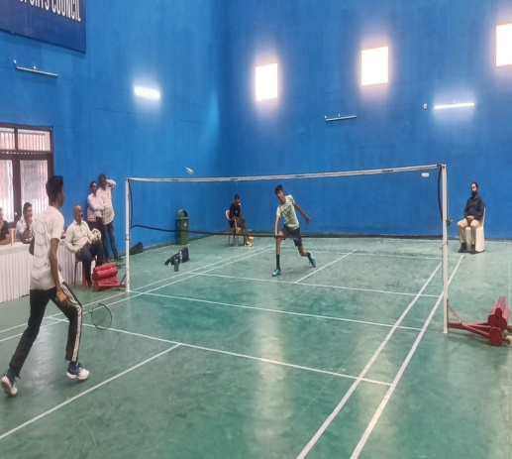

NIAS-ALC SESSION( OCTOBER 12,2023)
Session of NIAS- ALC was conducted on October 12,2023.The topic of discussion for the class was- “ Trignometry(Heights and Distance)”. Class was fully interactive and students took part in the discussion with great interest.
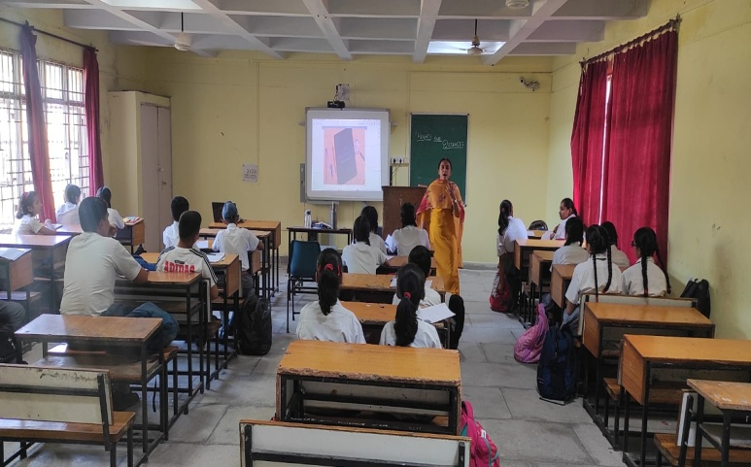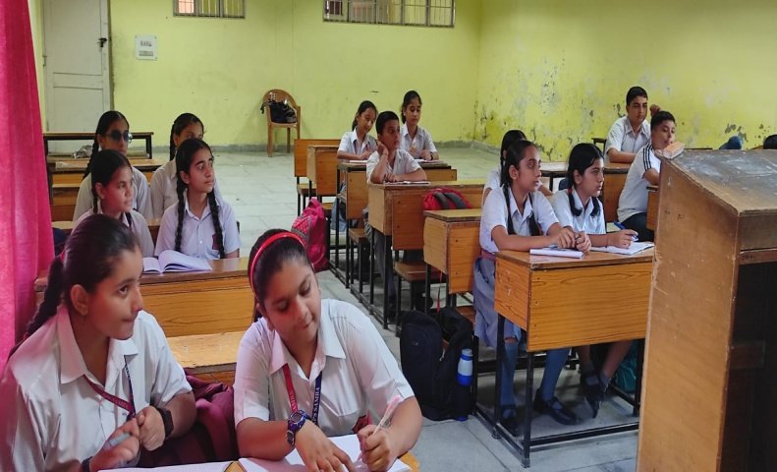

SPORTS ACTIVITIES FOR PRIMARY STUDENTS (I-V)(OCTOBER 13,2023)
To encourage physical activity among kids, various sports activities like lemon and spoon race, sack race,frog race etc. were organized for the students of classes I-V on October 13,2023 at APS Samba. The main objective of these sports activities was to encourage younger kids to spend more time outside and away from digital devices.
Through these activities we’re not only aiding the child’s physical well-being, but also helping them improve their emotional and intellectual well-being, too.These activities help children to learn many skills including coordination,balance and agility.After the sports activities ,the winners were felicitated with the medals.

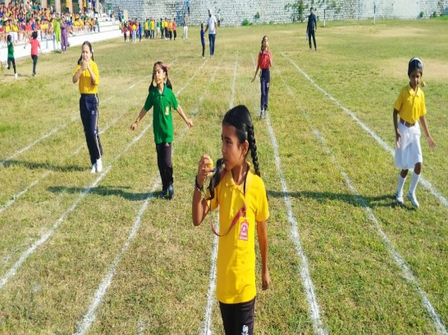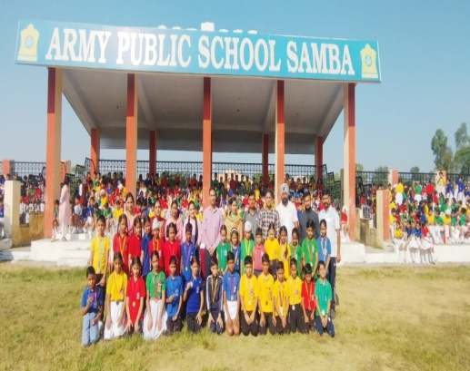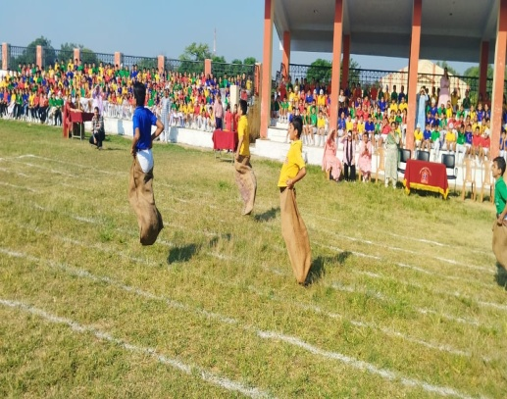

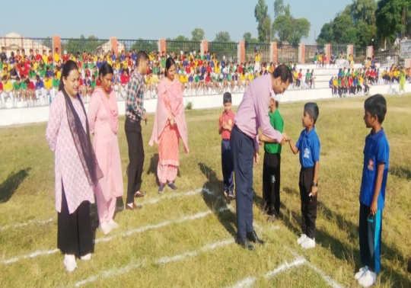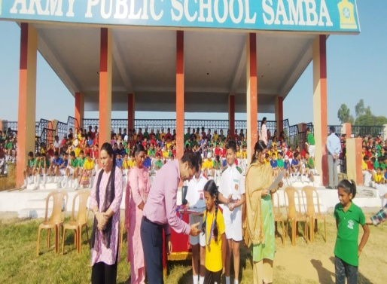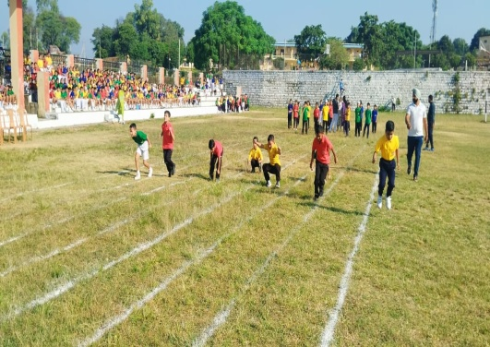

ONLINE INTER SCHOOL FEST - NAI SOCH – LOCAL TO GLOBAL (OCTOBER 14,2023)
Army Public School Noida organized an Inter School Fest- Nai Soch-Local to Global competition(ONLINE) on October 15,2023 which includes plethora of activities/events that will help inculcate competencies and abilities in the children of today and will also empower the youth of the country with globally relevant skill sets that will enable them to excel in their future endeavours. Students from APS Samba also participated in various activities like Dance,Salad making, PPT making,Trash to tiara etc. under this competition which were uploaded on the links provided by the school on October 14,2023.

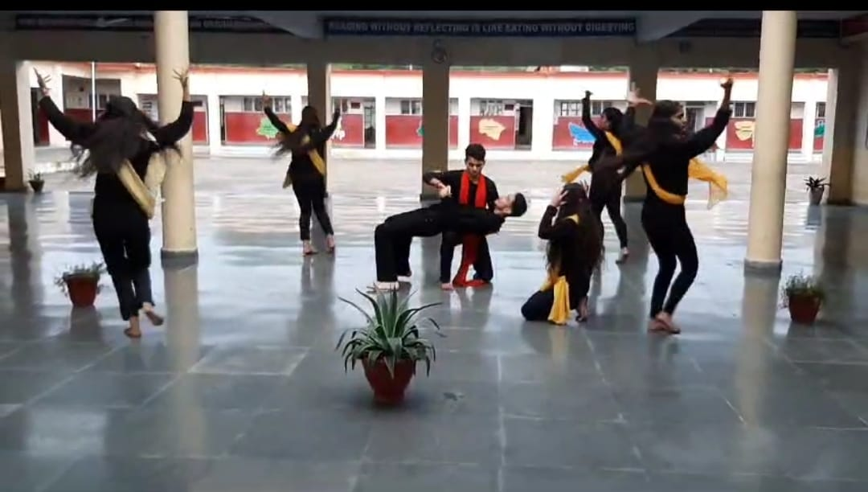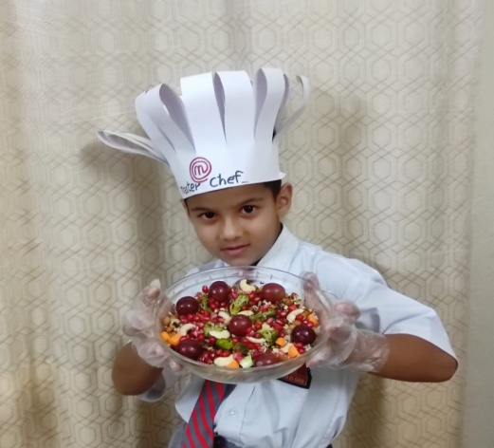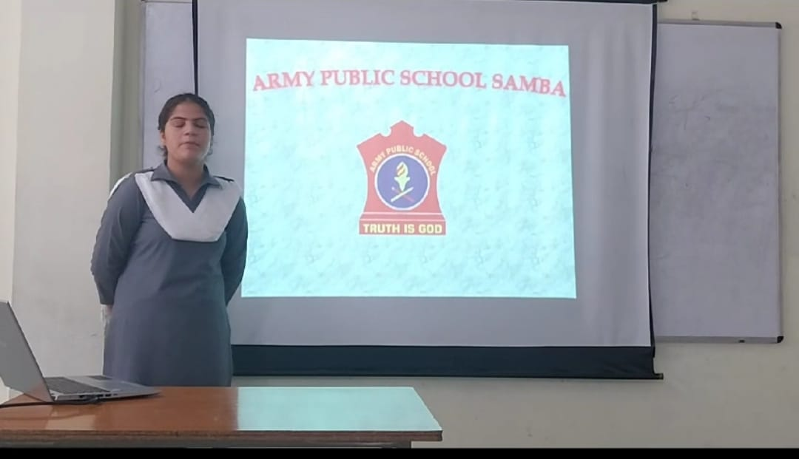

INTER HOUSE IMPROMPTU SPEAKING COMPETITION (OCTOBER 14,2023)
To test student’s creativity, presence of mind and command over language all within a span of one minute, an Inter House Impromptu Speaking Competition for the students of classes IX-XII was organized on October 14,2023. It invites the student speakers to speak on a given topic without hesitation, repetition or deviation.
The participants of all the four houses displayed their oratory skills and spoke empathetically on the allotted topics. This competition provided a platform for the students to show their talent and expertise in impromptu speech. The competition was adjudged by Ms. Taniya Sambyal and Ms. Prianka Slathia.In this competition, Teresa House bagged the first position. Sarojini House stood at the second position and Nehru House remained at the third position.
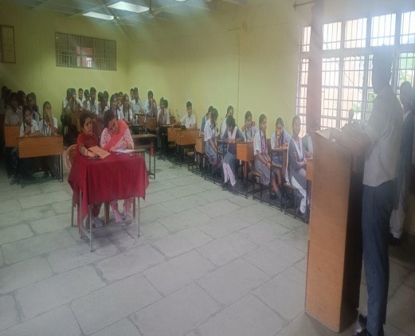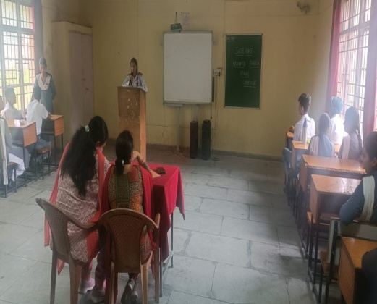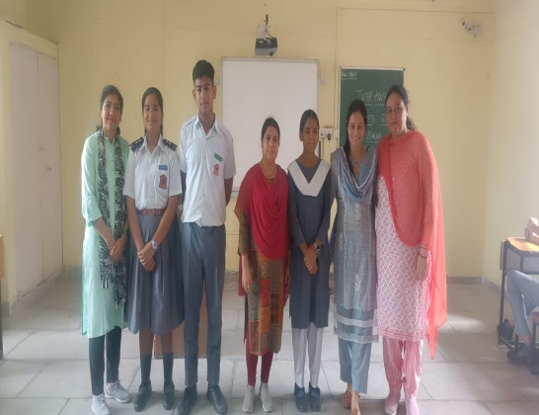

THANK YOU

